Numerical Methods- Questions
June 2018 Mathematics Advanced Paper 1: Pure Mathematics 1

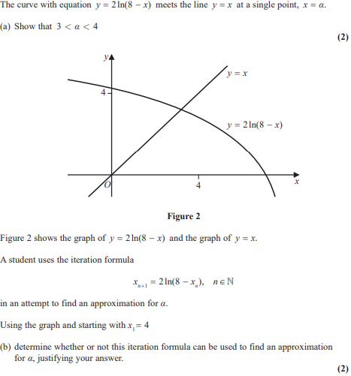

June 2017 Mathematics Advanced Paper 1: Pure Mathematics 3

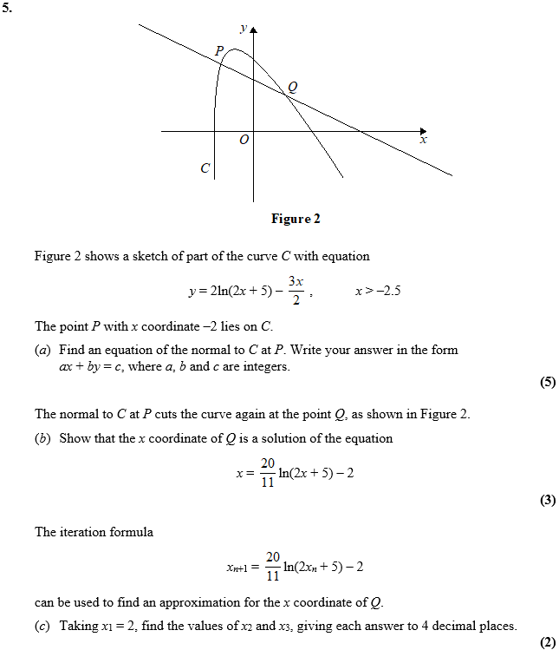

June 2016 Mathematics Advanced Paper 1: Pure Mathematics 3

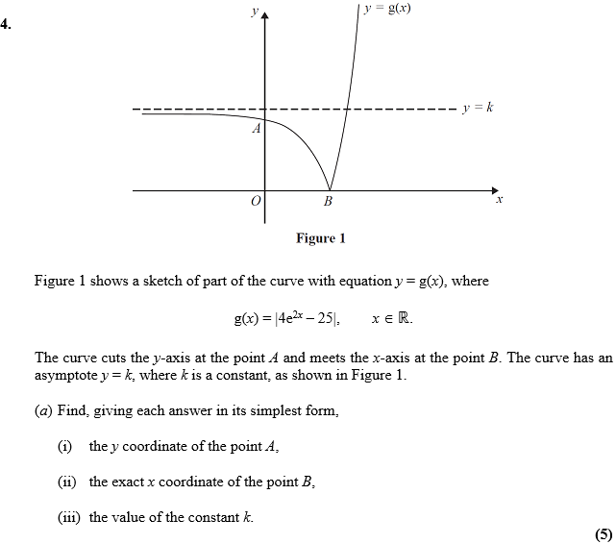
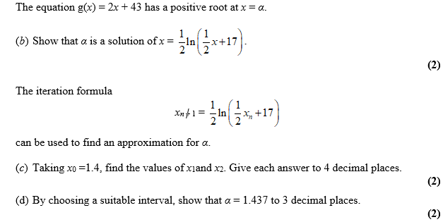

June 2015 Mathematics Advanced Paper 1: Pure Mathematics 3

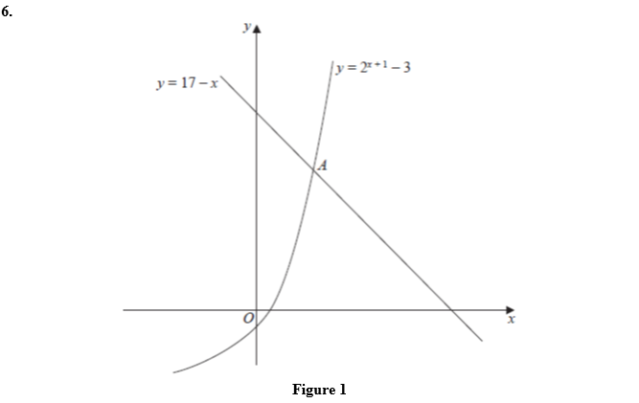
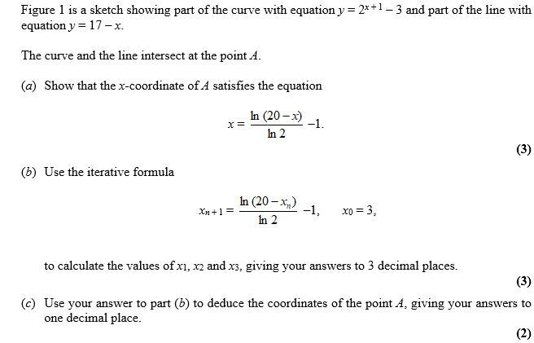

June 2014 Mathematics Advanced Paper 1: Pure Mathematics 3

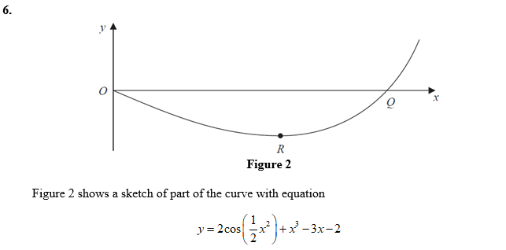

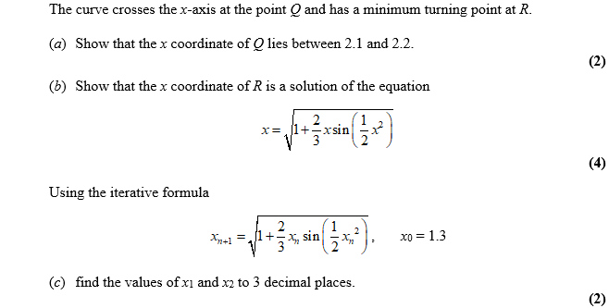

June 2013 Mathematics Advanced Paper 1: Pure Mathematics 3

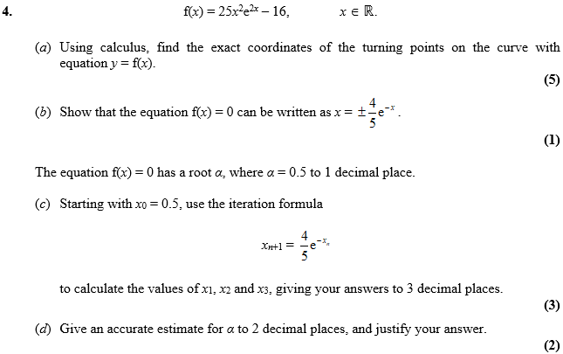
Jan 2013 Mathematics Advanced Paper 1: Pure Mathematics 3

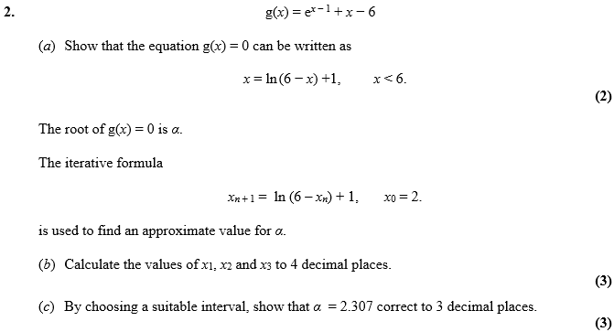

June 2012 Mathematics Advanced Paper 1: Pure Mathematics 3

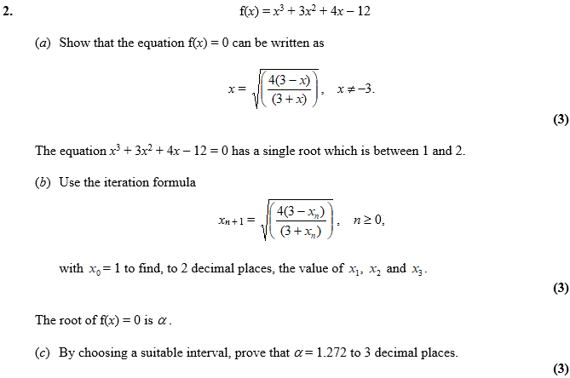

Jan 2012 Mathematics Advanced Paper 1: Pure Mathematics 3

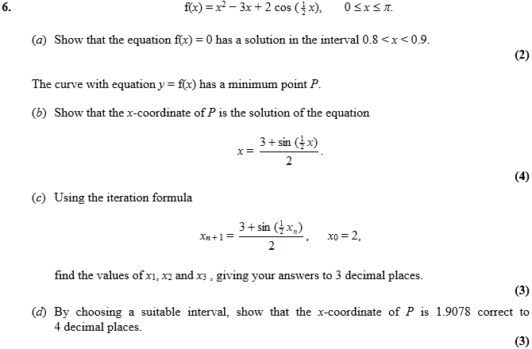
June 2011 Mathematics Advanced Paper 1: Pure Mathematics 3

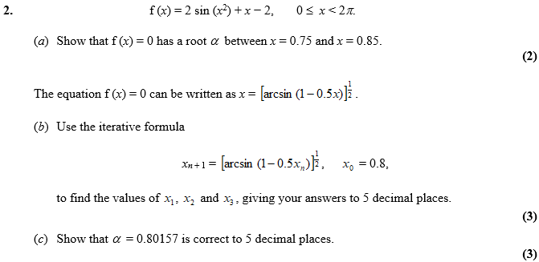

Jan 2011 Mathematics Advanced Paper 1: Pure Mathematics 3

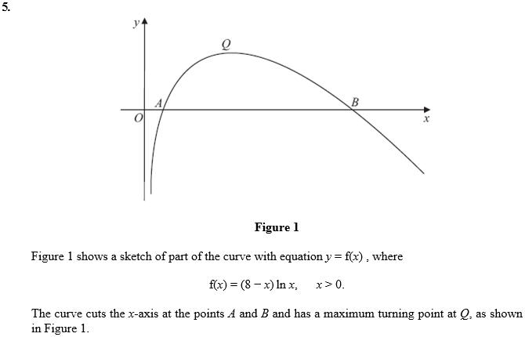
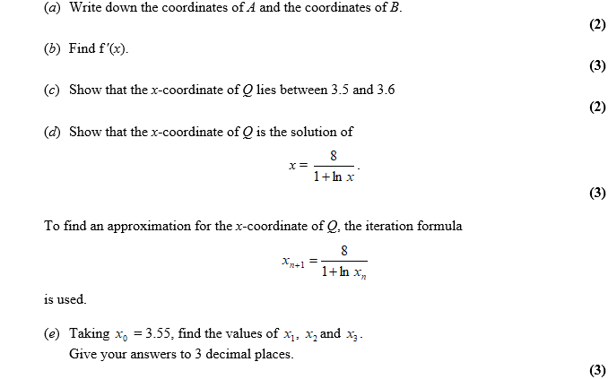
June 2010 Mathematics Advanced Paper 1: Pure Mathematics 3

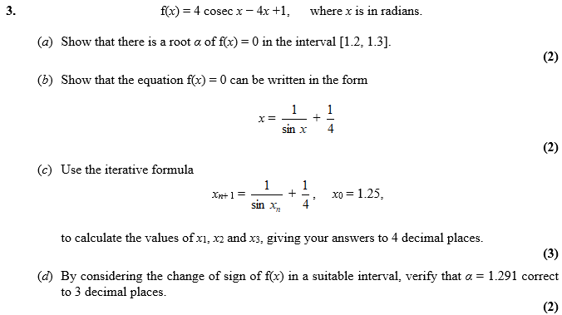

Jan 2010 Mathematics Advanced Paper 1: Pure Mathematics 3

